Assignment 2: Programming Activities

**Weight**: 15% of your final grade

**Due**: after Unit 2, Section 5 (ideally by the end of Week 8)

Combine all required activities in one file, name it COMP325_2_YYMM, and submit it to your tutor here for marking and feedback.

* Be sure to complete the final step—click on the **Send for Marking** button to notify your tutor.

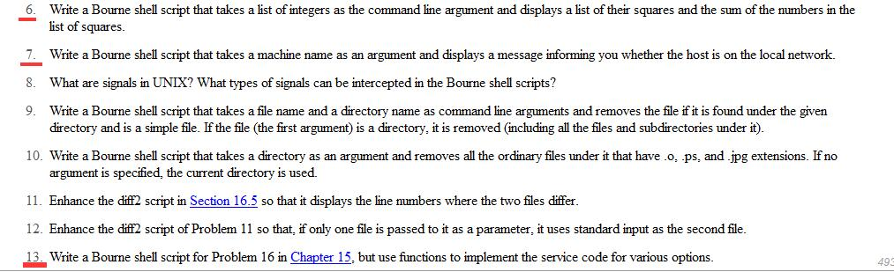

1. Write shell scripts specified in problem 6 at the end of Chapter 16. Test these scripts, and make sure that they work.

Script:

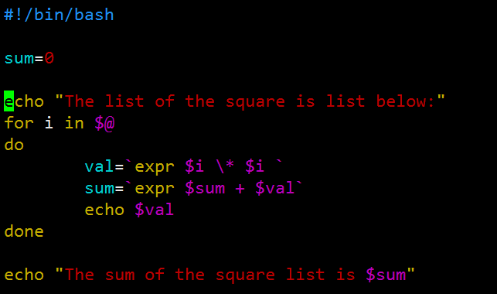

Result:

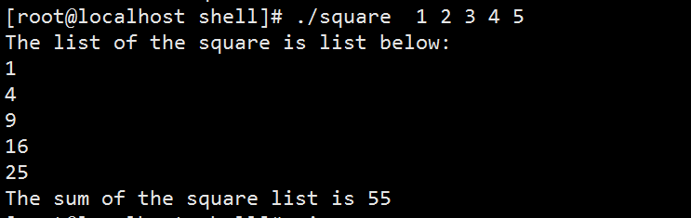

1. Write shell scripts specified in problem 7 at the end of Chapter 16. Test these scripts, and make sure that they work.
2. Write shell scripts specified in problem 13 at the end of Chapter 16. Test these scripts, and make sure that they work.